Individual Assignment (45%)

Big Data Processing – Movie Ratings

Objectives:
- Understand the process and requirements of loading Big Data.
- Processing Big Data using Databricks.
- Create visualizations of Big Data.

Instructions:
- This is an individual assignment.
- You can only use PySpark/Pandas DataFrame for the assignment. The use of SQL statements will not be accepted.
- Do note that if you are found to commit plagiarism, you will receive zero for your assignment.
- Module Assessment Weightage: 45%
- Marking rubrics for the conclusions are found on the last page of this document.

Deliverables:
- IT2312 2023 S2 Assignment.docx
  - Answers to the conclusion question written in the box provided.
- DataBricks DBC (*.dbc) Archive File
  - Codes (not SQL statements) that produce the solutions and visualizations for both Part 1 and Part 2.

Background
You are a data scientist looking working for a film production company. You have been tasked to, “Identify new movie genres to target and produce,” and “Identify examples and elements of bad movies to avoid replicating.” Your data mining goals include:
- What are the most popular movies among the uncommon genres.
- What are the worst and best movies based on average rating.
- What are the top tags that describe the worst movies.

The dataset used in this assignment (ml-25m) describes 5-star rating and free-text tagging activity from MovieLens, a movie recommendation service. It contains 25,000,095 ratings and 1,093,360 tag applications across 62,423 movies. These data were created by 162,541 users between January 09, 1995 and November 21, 2019. This dataset was generated on November 21, 2019.
Users were selected at random for inclusion. All selected users had rated at least 20 movies. No demographic information is included. Each user is represented by an id, and no other information is provided.
The data are contained in the files links.csv, movies.csv, ratings.csv and tags.csv. Note that we will be using only movies.csv, tags.csv and ratings.csv files for this assignment. More details about the contents and use of all these files can be found here: https://grouplens.org/datasets/movielens/

Part 1 – Data Ingestion (20 marks)
- Ingest the 3 files movies.csv, tags.csv and ratings.csv into DataBricks.
(10 marks)

- Print the number of records and the number of columns for each data file.
(10 marks)

Part 2 – Data Exploration (70 marks)
For the data exploration tasks below, please use a DataBricks Notebook to document what you did to create the required visualization or tables.
- Create a DataFrame showing the list of unique tags and the number of occurrences for each tag for tags that are NOT in the following list: ['sci-fi', 'action', 'comedy', 'mystery', 'war', 'politics', 'religion', 'thriller']. Sort the list in descending order by the number of tag occurrences. An example is shown below.
(10 marks)

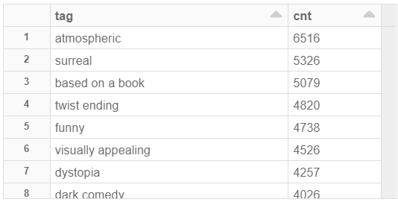

- Create a DataFrame that contains the movies with the tags of ‘boring’ and ‘overrated’. The view or DataFrame should also show the title of the movie and the average rating for the movie. Sort the list by average rating in ascending order and display the top 10 rows.
(5 marks)

‘boring’ and ‘overrated’

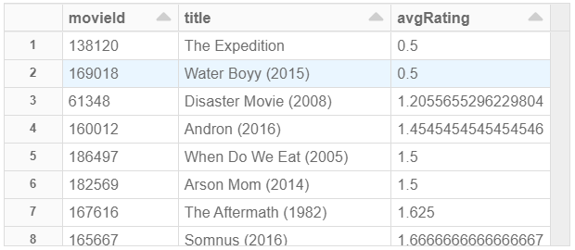
- Create a DataFrame that contains the movies with the tags of ‘great acting’ and ‘inspirational’. The DataFrame should also show the title of the movie and the average rating for the movie. Sort the list by average rating in descending order and display the top 10 rows.
(5 marks)
‘great acting’ and ‘inspirational’

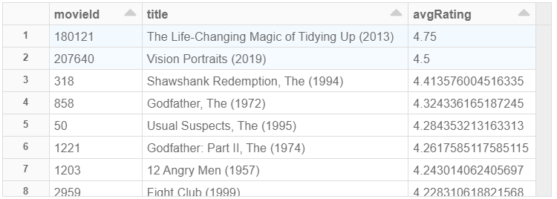

- Create a DataFrame that aggregates the movie ratings (r) into the ranges of: ‘Below 1’, ‘1 to 2’, ‘2 to 3’, ‘3 to 4’ and ‘4 to 5’ into a separate column named rating_range where:

Below 1 – r < 1
1 to 2 – r >= 1 and r < 2
2 to 3 – r >= 2 and r < 3
3 to 4 – r >= 3 and r < 4
4 to 5 – r >= 4 and r < 5

Include the columns userId, movieId, rating and tag in the DataFrame.
(10 marks)
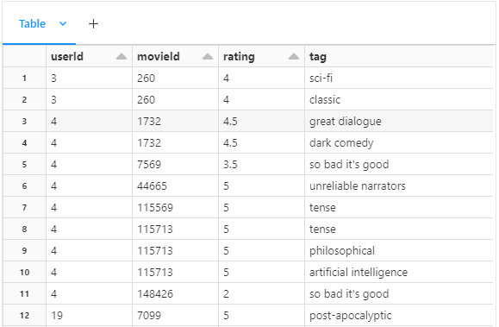
- Create a DataFrame that shows the aggregated movie rating ranges and their corresponding tags and count of the tags. Filter the view or table to show only tag counts that are more than 200. Sort the view or table by the rating range in ascending order and the tag counts in descending order.
(10 marks)

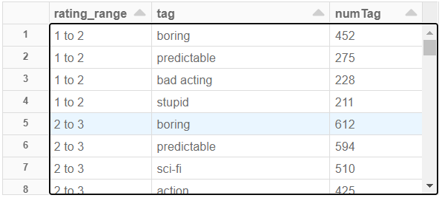

- What conclusions can you draw from the data exploration you have performed above?
(30 marks)

- Leverage Niche and Descriptive Tags for Marketing:
  - Conclusion: The analysis of tags not in the common list (sci-fi, action, comedy, etc.) shows that descriptors such as atmospheric, surreal, based on a book, and twist ending occur with high frequency.
  - Suggestion: Marketing and recommendation engines could benefit by highlighting these distinctive attributes. Emphasizing such unique features in movie promotions might attract audiences looking for films with particular moods or storytelling styles, thereby differentiating the content in a competitive market.
- Monitor and Address Negative Perceptions:
  - Conclusion: Movies tagged as boring and overrated consistently show very low average ratings (e.g., averages as low as 0.5 to 1.7). This clearly indicates that such negative tags are correlated with poor audience reception.
  - Suggestion: It would be wise to flag movies associated with these negative tags for further review. Content curators and recommendation systems should consider filtering or deprioritizing these titles to prevent user dissatisfaction. Additionally, studios could use this insight to reassess or repackage films that are initially perceived negatively.
- Promote Films with Positive Emotional and Performance Cues:
  - Conclusion: Conversely, movies carrying the tags great acting and inspirational are among the highest rated (with averages around 4.2 to 4.75). This suggests a strong positive correlation between these attributes and overall audience satisfaction.
  - Suggestion: Recommendation systems can leverage this finding by prioritizing films with these positive tags when targeting users who have historically enjoyed uplifting or performance-centric content. Studios might also focus on acquiring or producing films that emphasize strong acting and inspirational themes to tap into this favorable audience’s sentiment.
- Utilize Rating Range Segmentation to Fine-Tune Content Strategies:
  - Conclusion: Aggregating movie ratings into ranges such as Below 1, 1 to 2, 2 to 3, 3 to 4, and 4 to 5 revealed that many popular tags fall within the 2 to 3 range. This suggests that a significant number of movies are receiving moderate ratings.
  - Suggestion: This segmentation can be used to identify films that are performing in the mid-range and may benefit from targeted improvements or more effective marketing. For instance, exploring why certain tags are dominant in this mid-range can help in formulating strategies to boost the overall quality perception or to tailor recommendations for users with moderate taste preferences.
- Adopt Scalable and Resource-Efficient Data Techniques:
  - Conclusion: The data exploration utilized broadcast joins and early aggregations, which efficiently reduced the dataset size before executing complex joins and filtering. This approach allowed us to obtain insights without causing performance issues, even with large datasets.
  - Suggestion: Continuing to use resource-efficient methods—such as broadcast joins when merging large with small Data Frames and aggregating early in the data pipeline—will be essential for real-time monitoring and analysis. This ensures that the business can scale its data analysis processes to handle growing volumes of user and movie data without lag, supporting more agile and responsive decision-making.

Overall Business Impact:
- Enhanced User Recommendations: By understanding which tags are associated with high and low ratings, recommendation systems can be fine-tuned to avoid films likely to dissatisfy users while promoting those with attributes that resonate positively.
- Targeted Marketing: Niche descriptors uncovered through tag analysis can inform more focused marketing campaigns aimed at specific audience segments.
- Content Quality Feedback: Identifying clusters of negative tags helps studios and platforms identify potential quality issues, leading to improvements in production, acquisition, or even content curation.
- Operational Efficiency: Employing efficient data processing methods ensures that these insights can be gathered and updated regularly without significant resource overhead, making the approach sustainable in a real-world, high-volume environment.

Part 3 – Data Exploration (10 marks)
- Record a 5-minute presentation video presenting your answers and your conclusion and submit it on BrightSpace together with this document.
(10 marks)

Marking Rubrics for Conclusions

Needs Improvement | Developing | Sufficient | Above Average | Excellent
F | D to D+ | C to C+ | B to B+ | A to Dist
0 – 9 marks | 10 – 13 marks | 14 – 17 marks | 18 – 21 marks | 22 – 30 marks
Did not provide conclusions and/or suggestions that addressed the business objective/ problem. | Provided some conclusions and/or suggestions that did not adequately address the business objective/ problem. | Provided 1 or 2 conclusions and/or suggestions that adequately addressed the business objective/ problem. | Provided 2 or 3 conclusions and/or suggestions that addressed the business objective/ problem and provided some insights into possible solutions. | Provided 4 or more conclusions and/or suggestions that more than adequately addressed the business objective/ problem and provided valuable insights into possible solutions.

Marking Rubrics for Video Submission

Needs Improvement | Developing | Sufficient | Above Average | Excellent
F | D to D+ | C to C+ | B to B+ | A to Dist
0 – 4 marks | 5 – 5.5 marks | 6 – 6.5 marks | 7 – 7.5 marks | 8 – 10 marks
No key ideas; presentation shows no effort, organization, elaboration, and use of visuals and graphics.  Presenter appears very uncomfortable; displays very poor use of eye contact, posture, gestures, and vocal expressiveness. No effort to engage audience and lack fluency and good pronunciation.  Presented solution that is ambiguous and unorganized, and audience did not understand and could not follow. | Key ideas are unclear; presentation shows little effort, organization, elaboration, and use of visuals and graphics.  Presenter appears uncomfortable; displays poor use of eye contact, posture, gestures, and vocal expressiveness. Little effort to engage audience and lack fluency and good pronunciation.  Presented solution that is not clear and concise, and audience has difficulty understanding and following. | Key ideas lack clarity; presentation shows some effort, organization, elaboration, and use of visuals and graphics.  Presenter appears rather uncomfortable; displays limited use of eye contact, posture, gestures, and vocal expressiveness. Some effort to engage audience, fluency, and good pronunciation.  Presented solution with limited clarity and conciseness; audience sometimes find it challenging to understand and follow. | Key ideas presented clearly; presentation shows good effort, organization, elaboration, and use of visuals and graphics.  Presenter appears comfortable; displays good use of eye contact, posture, gestures, and vocal expressiveness. Good effort to engage audience, fluency, and pronunciation.  Presented solution clearly and concisely for audience understanding. | Key ideas presented very clearly and convincingly; presentation shows excellent effort, organization, elaboration, and use of visuals and graphics.  Presenter appears confident; displays effective use of eye contact, posture, gestures, and vocal expressiveness. Excellent effort to engage audience, fluency, and pronunciation.  Presented solution clearly, concisely, and convincingly.

